Andre Hardy – Project 5-2

13. Notice that your device is shown on a map regarding its current location. How accurate is this?
A: The location is accurate to my exact address

14. Click Hardware information. How accurate is this information?
A: The hardware information listed is accurate to my desktop PC
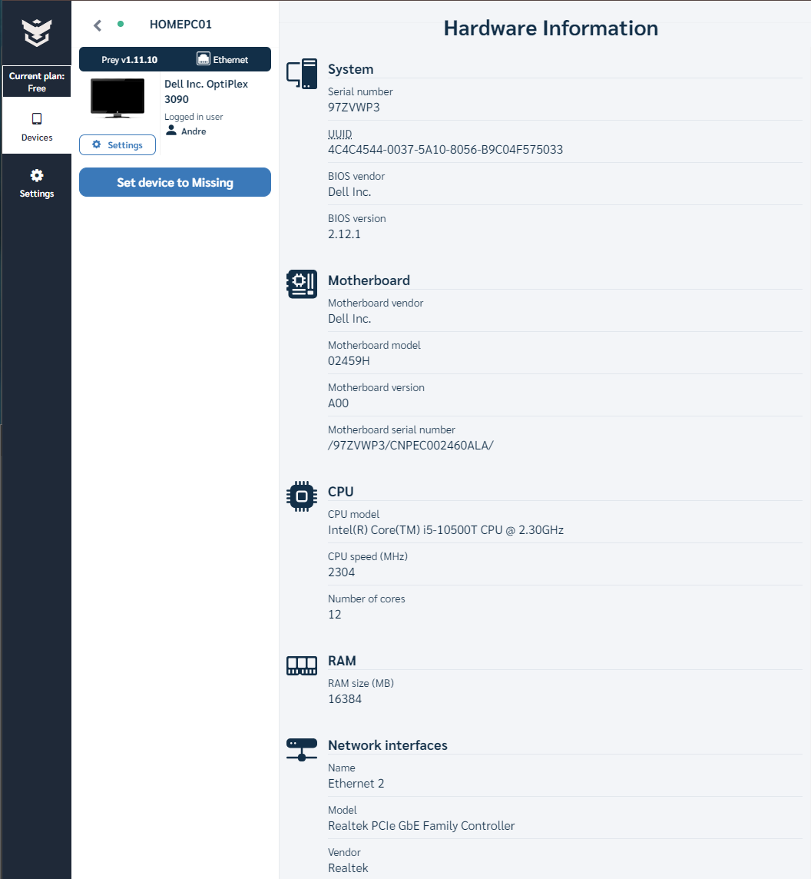

16. Under Actions in the right pane, click Sound alarm. Read the pop-up window about this function. How would it be useful? Depending upon your setting, either click Close (to cancel this) or Confirm (to sound the alarm).
A: This would be useful if your device is lost nearby

17. Under Actions in the right pane, click Send message. Click Confirm. Notice that the message appears on the screen. Is this wording strong enough to compel the person to return a missing laptop? Should a reward be offered? How would you frame this message?
A: Offering a reward may persuade whoever finds it to return it, however, this may also cause a “ransom” situation. The wording should not provide too much detail as to what data may be contained or how much monetary value it may be worth.
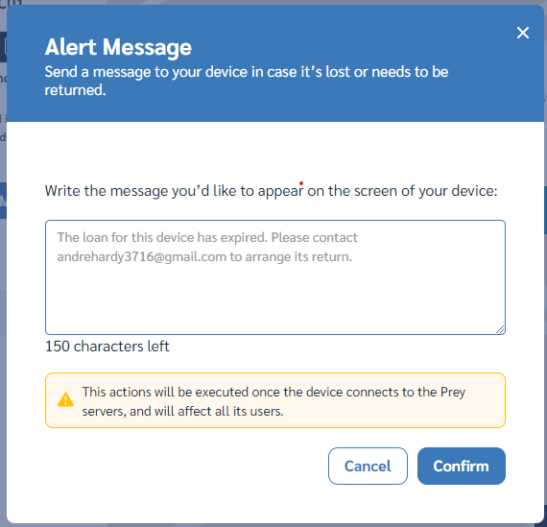
19. Under Actions in the right pane, click lock device. Read about the function this will perform. How useful would this be? Depending upon your setting, either click Close (to cancel this) or Confirm (to lock the device).
A: Remote locking the device could be useful in preserving the data and information stored on the device from unauthorized access.

21. Click Set device to missing and read through what occurs when this is selected. Click Advanced Options. How helpful would it be to have a photo of the person who is using the device and a screen capture of what they are doing on the device?
A: Taking a photo of the person using the device could help determine whether the device has fallen into the hands of a known user, a known thief, or an unauthorized individual who could later be tracked down using the image captured.
23. When a report is generated, click reports, and read the information about the location of the device. Would this be sufficient information to find the missing device?
A: I believe this would be sufficient identifying information.

